This is an open access article published under an ACS AuthorChoice License, which permits copying and redistribution of the article or any adaptations for non-commercial purposes.



Research Article

Cite This: *ACS Cent. Sci.* 2019, 5, 319−326



<http://pubs.acs.org/journal/acscii>

Ultranarrow-Band Wavelength-Selective Thermal Emission with Aperiodic Multilayered Metamaterials Designed by Bayesian Optimization

Atsushi Sakurai,†,‡ Kyohei Yada,§ Tetsushi Simomura,§ Shenghong Ju,‡,∥ Makoto Kashiwagi,∥ Hideyuki Okada,§ Tadaaki Nagao,‡,∇ Koji Tsuda,‡,⊥,# and Junichiro Shiomi*,‡,∥,#

†Department of Mechanical and Production Engineering, Niigata University, 8050 Ikarashi 2-no-cho, Niigata 950-2181, Japan

‡National Institute for Materials Science, 1-2-1 Sengen, Tsukuba 305-0047, Japan

§Graduate School of Science and Technology, Niigata University, 8050 Ikarashi 2-no-cho, Niigata 950-2181, Japan

Downloaded via SHANGHAI JIAO TONG UNIV on November 19, 2021 at 02:49:21 (UTC).

See https://pubs.acs.org/sharingguidelines for options on how to legitimately share published articles.

∥Department of Mechanical Engineering, The University of Tokyo, 7-3-1 Hongo, Bunkyo-ku, Tokyo 113-8654, Japan

⊥Graduate School of Frontier Sciences, The University of Tokyo, 5-1-5 Kashiwa-no-ha, Kashiwa 277-8561, Japan

#RIKEN Center for Advanced Intelligence Project, 1-4-1 Nihombashi, Chuo-ku, Tokyo 103-0027, Japan

∇Department of Condensed Matter Physics Graduate School of Science, Hokkaido University, Kita-10 Nishi-8, Kita-ku, Sapporo 060-0810, Japan

*S *Supporting Information*

All materials emit or absorb thermal radiation. Therefore, in the exploration to utilize various thermal energy resources, tailoring thermal radiation plays a fundamentally important

role.1−3 While conventional thermal radiators typically exhibit

broad-band, polarization-independent, and omnidirectional emission, the technology to control thermal radiation is rapidly progressing with the development of the ﬁelds of nanophotonics and metamaterials. Electromagnetic metamate-

consists of 2D-grating-coupled surface phonon polaritons. However, there is still a problem because there are large unwanted peaks and background in the emissivity spectra in the target wavelength range. This can be quantiﬁed by the low value of the ﬁgure of merit (deﬁned to evaluate the radiator performance as will be shown later) due to the low wavelength selectivity. In addition, including another experimental demonstration of multiple quantum wells and a photonic

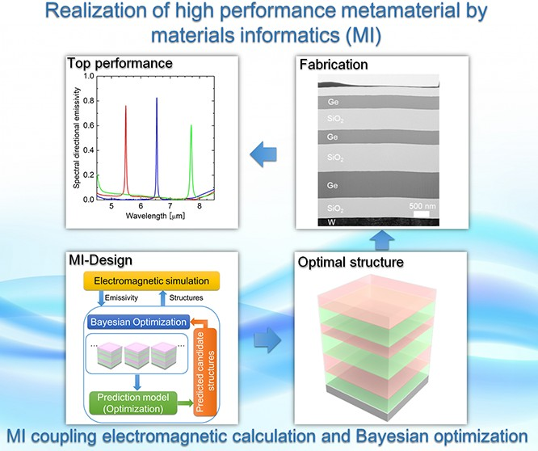

ABSTRACT: We computationally designed an ultranarrow-band wavelength-

selective thermal radiator via a materials informatics method alternating between Bayesian optimization and thermal electromagnetic ﬁeld calculation. For a given target infrared wavelength, the optimal structure was eﬃciently identiﬁed from over 8 billion candidates of multilayers consisting of multiple components (Si, Ge, and SiO2). The resulting optimized structure is an aperiodic multilayered metamaterial exhibiting high and sharp emissivity with a Q-factor of 273. The designed metamaterials were then fabricated, and reasonable experimental realization of the optimal performance was achieved with a Q-factor of 188, which is signiﬁcantly higher than those of structures empirically designed and fabricated in the past. This is the ﬁrst demonstration of the experimental realization of metamaterials designed by Bayesian optimization. The results facilitate the machine-learning-based design of metamaterials and advance our understanding of the narrow-band thermal emission mechanism of aperiodic multilayered metamaterials.

■

INTRODUCTION

thermal radiator with the highest Q-factor to date (∼200)

28

29

rials are artiﬁcially engineered materials with characteristics

crystal slab with a Q-factor of 107,

the complicated

tailored over a broad range of wavelengths.4,5 Wavelength- selective narrow-band thermal emission control is a key technology with applications in high-eﬃciency thermophoto-

voltaics,6−8 incandescent light sources,9 biosensing,10−12

microbolometers,13,14 imaging,15 and infrared heaters.16 Diﬀer- ent types of artiﬁcial nanostructures have been proposed in the past few decades: multilayer,17,18 photonic crystal,19−21 and

metal−insulator−metal (MIM) metamaterials.22−27

Development of metamaterial thermal radiators generally

requires high-cost nanofabrication. The reported narrow-band

fabrication process faces practical problems because many

applications of radiators require large surface area. In this sense, among various classes of metamaterials, multilayers with relatively less complication in fabrication have merit in scalability. Control of thermal emission by multilayer

structures has been successfully demonstrated with a Fabry− Perot resonator with a Q-factor of 8730 and a distributed Bragg

Received: November 1, 2018

Published: January 22, 2019

© 2019 American Chemical Society 319 DOI: [10.1021/acscentsci.8b00802](http://dx.doi.org/10.1021/acscentsci.8b00802)



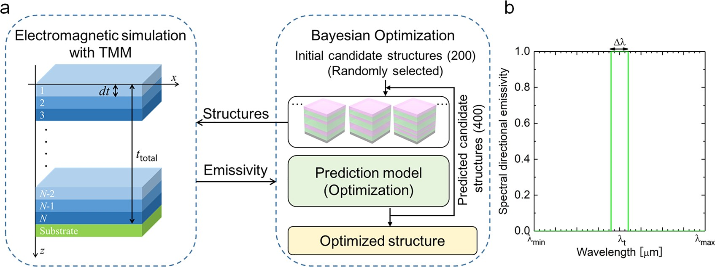

Figure 1. (a) Schematic of the optimization method with material informatics combining electromagnetic simulation and Bayesian optimization.

(b) Schematic of the ideal optical property of the narrow-band thermal radiator.

reﬂector with a Q-factor of 36.31 However, these structures are usually realized by simple and periodic design, despite the fact that periodic structures are a tiny subset of the entire possible

range of multilayer structures. Several studies have reported control of light by such “aperiodic” multilayer structures,32−36

but these results were obtained by numerical simulation. Furthermore, the optimal design of aperiodic multilayered metamaterials with desired thermal emission characteristics has been diﬃcult because the search space, i.e., the number of possible candidates, becomes enormous.

The key technology to overcome this challenge is “materials informatics” (MI), which has the capability to eﬃciently identify materials with preferred properties. MI aims to identify the “best” materials with optimal structure and/or composition using unrecognized complex correlations in the data. It has been applied to ﬁnd novel materials such as cathode materials for the lithium-ion batteries,37 nitride semiconductors composed of earth-abundant materials,38 piezoelectric materi-

als,39 and thermoelectric materials.40−44 While these works

have aimed to realize high-throughput screening of the best materials from the pool of stoichiometric compounds, another course of MI aims to create nanostructures by identifying the optimal geometry that maximizes the objective properties. This includes nanoparticles embedded in a matrix to modulate heat

conduction,45 solid−solid interfaces to identify energetically stable structures,46 and multicore structures of plasmonic

nanowires to control optical scattering and cloaking eﬀects.47 On the basis of the above progress in geometry optimization,

the methodology using Bayesian optimization has been extended to the design of nanostructures with optimal thermal conductance48 and thermoelectric ﬁgure of merit.49 There, to eﬃciently identify the optimal structures among the enormous number of candidates, phonon/electron transport calculations and machine learning/prediction are alternately conducted.

The previous works have shown that such an approach can considerably accelerate nanostructure design for transport properties. As the method is not limited to phonons/electrons and is applicable to any other quasi-particles, this work aims to perform such optimization for polaritons and associated thermal radiation. It should be noted that for thermal radiation there have been reports on the optimal design of multilayer

structures using a genetic algorithm,50,51 but genetic algorithms

do not involve machine learning/prediction. In addition, recent studies52,53 reported numerical nanophotonics designs based on neural networks. The essential drawback of their

approach is that it is “exploitation-only”. There is plenty of evidence that the exploitation-only approach cannot be more eﬃcient than the approach balancing exploitation and exploration.54 On the other hand, Bayesian optimization identiﬁes an unknown function with respect to the descriptors with as few iterations as possible, where, at every iteration, learning and prediction based on a Gaussian process are performed. Our approach uses Bayesian inference to quantify uncertainties and takes the optimal balance between exploration and exploitation, and we have used it to solve an essentially more diﬃcult problem than the ones solved using neural networks. Although the previous studies optimized the thickness of each layer only, we optimized how the three materials are arranged, i.e., our method optimizes the ordering

of the materials as well. There are a huge number of possible orderings, which adds substantial diﬃculty to the optimization problem.

In this work, we computationally designed an ultranarrow- band wavelength-selective thermal radiator via Bayesian optimization methods55 and experimentally demonstrated the optical characteristics of the designed multilayered metamate-

rials. Potential applications of this study include infrared sensors, infrared imaging, and infrared heaters since the target wavelength is in the mid-infrared range.

# RESULTS AND DISCUSSION

Figure 1a shows a schematic of the optimization method with

MI combining electromagnetic simulation and Bayesian optimization. The designed metamaterial is divided into *N* unit layers with thickness d*t*. A unit layer can be either Ge, Si, or SiO2. The choice of compositions are commonly used semiconductor and dielectric materials for their high and low refractive indices, respectively. Since tungsten was chosen as the substrate, the substrate was considered opaque. Four basic elements are required when materials informatics is performed: the descriptor, calculator, evaluator, and optimization method. The descriptors are used to describe possible structure candidates during the optimization process. In this study, we used a text ﬂag to indicate the state of each layer: “1”, “2”, and “3” represent the Ge, Si, and SiO2 layers, respectively. Such a simple descriptor has been shown to realize eﬃcient optimization48,49 in addition to being intuitive, general, and practical, which are important in the actual material develop- ment. As for the calculator, we employed the transfer matrix

method (TMM) to calculate the emissivity spectra (see Methods).

The desired optical property of the ultranarrow-band thermal radiator is shown in Figure 1b. The ideal radiator has a sharp and high thermal emission at a target wavelength λt with a bandwidth Δλ, and low thermal emission in the rest of the infrared wavelength region to reduce radiative heat loss. For the evaluator of designed multilayered metasurfaces, a ﬁgure of merit (FOM) is deﬁned as follows:

the global best structure was identiﬁed by ranking these 42 000 local best structures. The total computational time was about 24 days on our cluster machine with 24 parallel computation (UNI-i9X, TOWA Electric, Inc.). The computational memory size in this work was about 128 GB, which set the maximum total number of layers to be 18. This could be enlarged by using a computer with a larger memory, but as the FOM of the designed structure is already close to unity, there is in fact not much room left for noticeable improvement even if we further

∫ *λ*t+Δ*λ*/2

*ελI*b*λ* d*λ*

∫ *λ*t−Δ*λ*/2

*ελI*b*λ* d*λ*

increased the number of layers. Therefore, one can see the current setup to be nearly optimal and free from hardware

FOM =

*λ*t −Δ*λ* /2

*λ*t+Δ*λ*/2

− *λ*min

*λ*t−Δ*λ*/2

restrictions.

∫

*λ*t−Δ*λ*/2

∫ *λ*max

*I*b*λ* d*λ*

*ελI λ* d*λ*

∫

*λ*min

*I*b*λ* d*λ*

The resulting optimized structures are shown in Figure 2a. It is interesting to note that the optimized structure with the

*λ*t+Δ*λ*/2 b

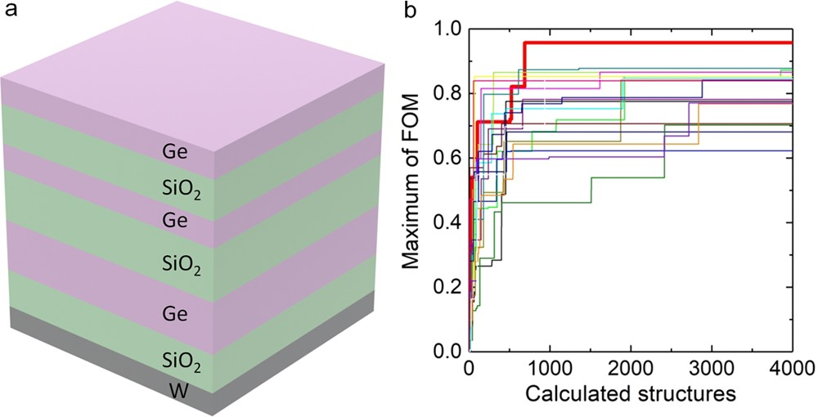

− *λ*

∫ max

*I λ* d*λ*

*λ*t+Δ*λ*/2 b

(1)

where ελ is the spectral normal emissivity, *I*bλ is the spectral blackbody intensity, and λmin and λmax are the minimum and maximum wavelengths considered for the optimization.

As we have *N* unit layers and three possible materials (Ge, Si, or SiO2), the total number of candidate structures is 3*N*, which becomes enormous for a useful range of *N*. For these large-scale problems, eﬃciency of optimization becomes critical, and thus, we need a method that surpasses conven- tional optimization tools. For this, we employ Bayesian optimization using the open-source library COMBO (see section S1 in the [Supporting Information](http://pubs.acs.org/doi/suppl/10.1021/acscentsci.8b00802/suppl_file/oc8b00802_si_001.pdf)).

As shown in Figure 1a, suppose that FOMs of *n* candidates

are initially calculated, and we are to select the next ones to calculate. A Bayesian regression function is learned from *n*

Figure 2. (a) Optimized structure of the narrow-band thermal emitter with three material candidates (Ge, Si, and SiO2). The optimal structure turned out to consist of only Ge and SiO2 layers. (b) Histories of the FOMs of 20 randomly selected groups. The global- maximum FOM was found in a certain group that is indicated by the thick red line.

pairs of descriptors and FOMs (i.e., training examples). For all

of the remaining candidates, a predictive distribution of FOMs is estimated. Finally, FOMs are calculated for the selected

candidates, and they are added to the training examples. By repetition of this procedure, the calculation of FOMs is scheduled optimally, and the optimized structure can be found quickly. Here, one problem is that the Bayesian optimization requires large computational memory because it uses information on the text data for all of the candidates. Therefore, we employed a hierarchical method to reduce the required size of computational memory, as will be explained later (also see [Figure S1](http://pubs.acs.org/doi/suppl/10.1021/acscentsci.8b00802/suppl_file/oc8b00802_si_001.pdf)).

First, we computationally designed narrow-band thermal radiators with three candidate materials (Ge, Si, and SiO2) for a target wavelength λt of 6.0 μm. The wavelengths Δλ, λmin, and λmax were set to 4 nm, 4 μm, and 8 μm, respectively. The

number of layers *N* was ﬁxed at 18. Variation of the total

thicknesses of the multilayers, *t*total, was also considered within the range from 3.6 to 4.0 μm with an increment of 0.02 μm, giving 21 variations of *t*total. Therefore, the total number of possible candidates is 318 × 21 = 8 135 830 269. It should be noted that it was not possible to account for structures with translational and reversal symmetries prior to the calculation to reduce the number of candidates. In this case, the numbers of

initial and predicted candidate structures were set to 200 and 400, respectively. The computational load for this calculation was so large that all of the candidates could not be evaluated. For the sake of saving the computational memory, the optimization was pursued in hierarchical steps; the overall candidates were randomly divided into 42 000 groups, and the optimization was ﬁrst performed for each group, after which

maximum FOM consists of only Ge and SiO2 layers despite the fact that the optimization was performed including Si also. The obtained structure is a counterintuitive aperiodic multi- layer, which is explicitly diﬀerent from conventional multi- layered thermal radiators with periodic structures. The total thickness *t*total of the optimal multilayer in this case is 3.80 μm. Figure 2b shows the history of the maximum FOM with respect to the number of calculated structures. Here we randomly chose the cases of 20 groups with about 200 000 candidates each to show the optimization eﬃciency and its statistics. The maximum FOM could be realized within calculations of 168 000 000 structures on average, which means only 2.06% of the candidate structures needed to be

calculated to identify the optimal structure.

We also designed two other types of narrow-band thermal radiators with diﬀerent target wavelengths of 5.0 and 7.0 μm. For these cases, using the ﬁnding in the case of λt = 6.0 μm that the optimal structure consists only of two species (Ge and SiO2), the optimization was performed for these two species instead of the above three species, which reduced the number of candidates to 218 × 21 = 5 505 024. The bandwidth Δλ (=4 nm) and the evaluation range of wavelengths (λmin = 4.0 μm and λmax = 8.0 μm) were kept the same as in the three-species optimization, and the number of initial candidate structures and predicted candidate structures were reduced to 100 and 20, respectively. The resulting optimized structures for λt = 5.0 and 7.0 μm (Figure 3a,b) consist of aperiodic multilayers similar to that for λt = 6.0 μm. The total thicknesses of the

321 DOI: [10.1021/acscentsci.8b00802](http://dx.doi.org/10.1021/acscentsci.8b00802)

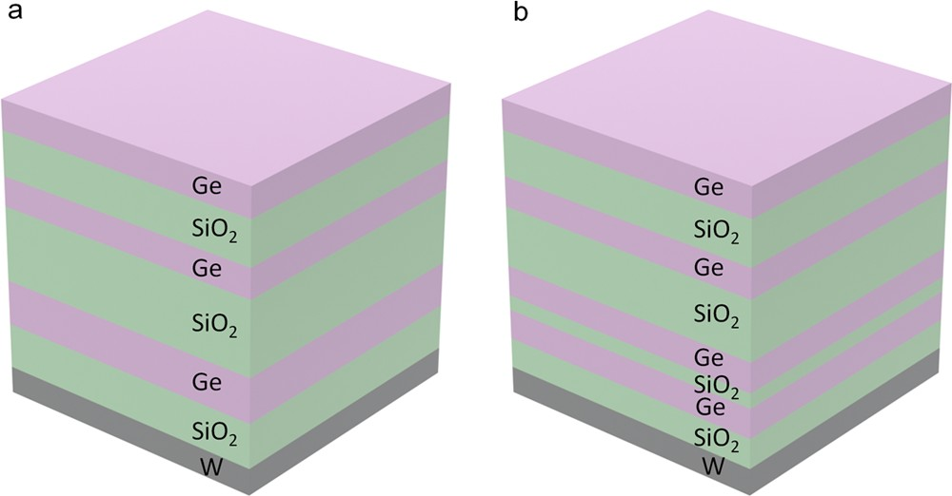

Figure 3. Optimized structures of the narrow-band thermal emitters for the target wavelengths of (a) 5.0 and (b) 7.0 μm.

multilayers for the corresponding samples are *t*total = 3.78 and

3.96 μm, respectively.

The computational load for the two-species calculations was relatively small, so all of the candidates could be calculated to validate the optimal structure and eﬃciency. As a result, the optimal structures obtained by Bayesian optimization were conﬁrmed to be exactly the same as the structures with maximum FOM among all of the candidates. We also conﬁrmed from the probability distributions (see [Figure S2](http://pubs.acs.org/doi/suppl/10.1021/acscentsci.8b00802/suppl_file/oc8b00802_si_001.pdf)) that the probability monotonically decreases as the FOM value approaches the maximum without noticeable local minima, indicating that the current problem is suited for Bayesian optimization.

Figure 4a shows the corresponding calculated spectral directional emissivities of the optimized structures. Extremely sharp and high emissivity can be realized with the optimized structures, and there are no extra peaks within the wavelength range of interest (from 4 to 8 μm). The corresponding emissivities of the peaks are unity, and their Q-factors are 217, 273, and 233 for λt = 5, 6, and 7 μm, respectively.

Finally, we experimentally fabricated the optimized

structures by sputtering to demonstrate the feasibility of the structural optimization. Figure 4b shows the measured spectral directional emissivities of the fabricated structures. The three sharp peaks that correspond to the ones seen in the numerical simulations can be clearly observed, although the locations of the peaks are shifted by about 0.5 μm relative to the designed structures. The obtained peak emissivity values of the λt = 5, 6, and 7 μm samples are 0.76, 0.83, and 0.61, and the Q-factors

are 132, 188, and 109, respectively. The reason for the

discrepancies in the peak positions and emissivities/Q-factors of the designed and fabricated structures could be that the thicknesses of the constituent layers in the fabricated samples somewhat deviate from the designed values. Table 1 quantiﬁes

Table 1. Layer Thicknesses of the Designed and Fabricated Structures (in μm)

|  |  |
| --- | --- |
| λt = 5.0 μm λt = 6.0 μm layer no. sim. exp. sim. exp. | λt = 7.0 μm |
| sim. exp. |

|  |  |  |  |  |  |  |  |
| --- | --- | --- | --- | --- | --- | --- | --- |
| 1 | 0.42 | 0.42 |  | 0.42 | 0.43 | 0.44 | 0.44 |
| 2 | 0.63 | 0.61 |  | 0.63 | 0.69 | 0.66 | 0.62 |
| 3 | 0.42 | 0.43 |  | 0.42 | 0.45 | 0.44 | 0.44 |
| 4 | 1.05 | 0.97 |  | 0.85 | 0.91 | 0.88 | 0.84 |
| 5 | 0.63 | 0.63 |  | 0.85 | 0.87 | 0.44 | 0.45 |
| 6 | 0.63 | 0.58 |  | 0.63 | 0.65 | 0.22 | 0.22 |
| 7 | − | − |  | − | − | 0.44 | 0.44 |

8 − − − − 0.44 0.41

the moderate but non-negligible diﬀerences between the layer thicknesses of the designed and fabricated structures obtained from the cross-sectional transmission electron microscopy (TEM) image for λt = 6.0 μm (Figure 4c) and the cross- sectional scanning electron microscopy (SEM) images for λt =

* 1. μm and λt = 7.0 μm ([Figure S3](http://pubs.acs.org/doi/suppl/10.1021/acscentsci.8b00802/suppl_file/oc8b00802_si_001.pdf)). When we calculated the spectral directional emissivity for the layer thicknesses in the fabricated sample (Table 1), the position of the peak approached the experimentally measured value ([Figure S4](http://pubs.acs.org/doi/suppl/10.1021/acscentsci.8b00802/suppl_file/oc8b00802_si_001.pdf)). The remaining discrepancy can be attributed to the minor diﬀerences in the optical properties of the sputtered material and those used as inputs to the numerical simulation, since the optical properties may diﬀer depending on fabrication conditions such as the deposition rate.

To determine the sharpness of the interface, the atomic concentrations at the Ge−SiO2 interface were observed by energy-dispersive X-ray spectroscopy (EDX) ([Figures S5 and](http://pubs.acs.org/doi/suppl/10.1021/acscentsci.8b00802/suppl_file/oc8b00802_si_001.pdf) [S6](http://pubs.acs.org/doi/suppl/10.1021/acscentsci.8b00802/suppl_file/oc8b00802_si_001.pdf)), and the interface was conﬁrmed to be sharp with small interdiﬀusion. Although fabrication with a more accurately

calibrated sputtering process would improve the reproduction of the designed performance, which remains to be our future task, the key features in the designed structure, namely, ultranarrow-band emission with controlled peak wavelength,

were clearly realized in the experiments. The obtained Q- factors are about 217−273 in the computational design and about 109−188 in the experiment, which are signiﬁcantly

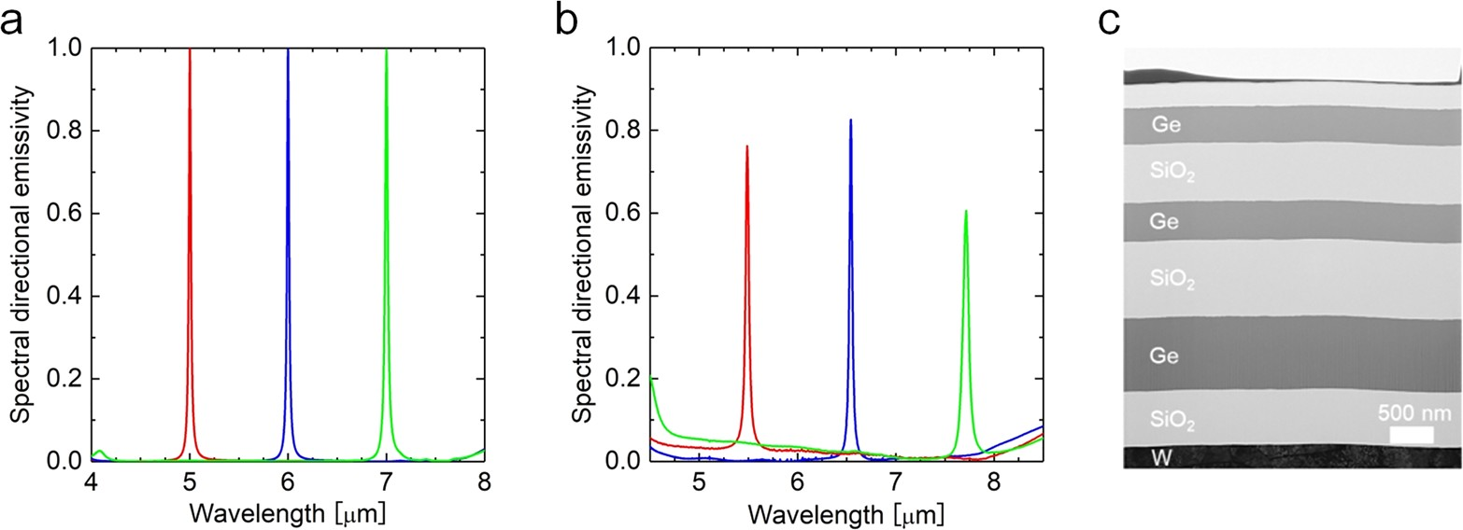

Figure 4. (a) Calculated spectral directional emissivities of the optimized structures obtained with Bayesian optimization and (b) measured spectral directional emissivities of the fabricated structures aimed at λt = 5.0 μm (red), 6.0 μm (blue), and 7.0 μm (green). (c) Cross-sectional TEM images of the fabricated sample for λt = 6.0 μm.

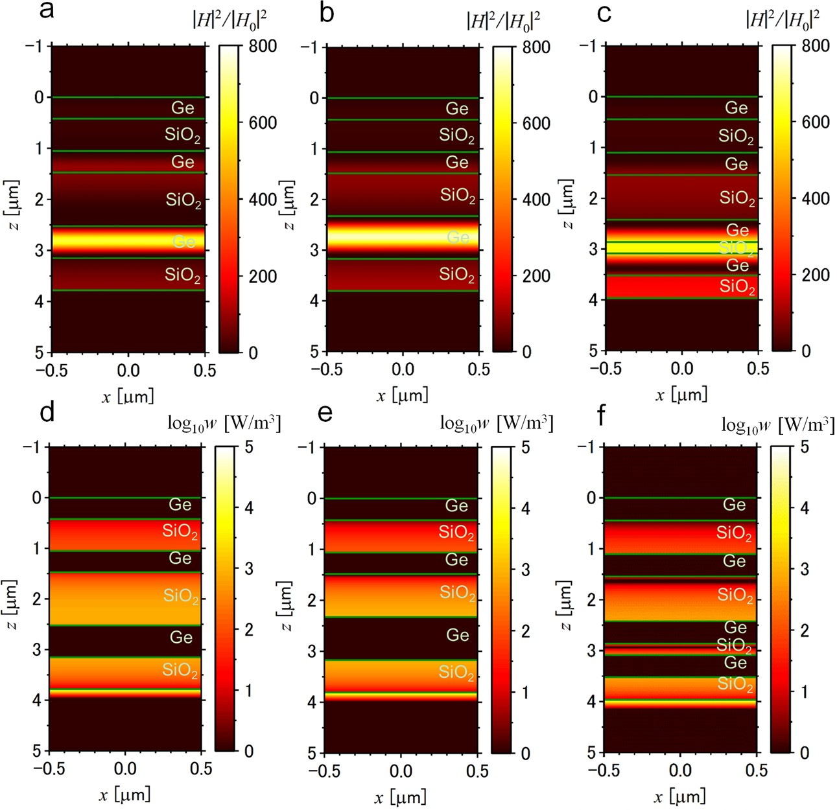

Figure 5. (a−c) Contour plots of normalized magnetic ﬁeld intensity and (d−f) power dissipation density for target wavelengths of (a, d) 5.0 μm, (b, e) 6.0 μm, and (c, f) 7.0 μm.

higher than the values reported in the previous studies. In addition, the FOM of this work is signiﬁcantly higher than in previous experimental work:28 the FOM of previous work, evaluated with the same wavelength range around the target wavelengths, was only 0.02 for 0° and further decreased to

−0.16 for 1°, which are considerably smaller than the FOM of

0.77 for the current structure aimed at 6 μm. Although the locally extracted Q-factor in the previous work reached 200,28

aperiodic structure, when optimized, successfully suppresses the unnecessary emissivity peaks due to higher-order harmonics, or in other words, shifts the peaks to a shorter wavelength range. To quantify how much power is absorbed by the proposed structure, the power dissipation density *w* was calculated as57

*w* = 1 *ε ε*″*ω* |**E**|2

the emissivity spectra had much larger background and 2 0

unwanted peaks, and thus, our experiment exhibits signiﬁcantly

(2)

higher wavelength selectivity. To our knowledge, this is the ﬁrst demonstration that narrow-band thermal radiators designed by machine learning can be realized in experiments. We now discuss the mechanism of the enhanced emission in terms of the magnetic ﬁeld proﬁles shown in Figure 5. The intensities of the magnetic proﬁles were normalized by the intensity of the normal incident light. In Figure 5a,b for λt = 5 and 6 μm, there are strong conﬁnements of electromagnetic energy in the Ge layer. On the other hand, in Figure 5c, for λt

= 7 μm, strong conﬁnement can be observed in the SiO2 layer.

These emissivity enhancements originate from localized modes, similar to defect modes of photonic crystals.56 Defect modes of photonic crystals exist inside a photonic band gap; therefore, this phenomenon is usually observed with periodic structures (see [section S3](http://pubs.acs.org/doi/suppl/10.1021/acscentsci.8b00802/suppl_file/oc8b00802_si_001.pdf)). However, it is interesting to note

that we observed a similar localized mode inside the aperiodic multilayered metamaterials. In other words, two or more optimized defect layers are introduced into the photonic crystals that eﬀectively serve to constitute a sharp peak in the emissivity. In particular, in Figure 5c, the defect layer corresponds to three layers of a thin SiO2 layer and upper and lower Ge layers sandwiching the SiO2 layer. Therefore, the

where ε0 is the permittivity of vacuum, ε″ is the imaginary part of the complex dielectric function, and ω is the angular

frequency. The power dissipation densities, which are shown in Figure 5d−f, indicate the strong absorption at the tungsten substrate, although there is weak absorption within the SiO2 layer. Therefore, thermal energy dissipation mainly occurs in

the metallic substrate because of the large optical loss. Because of the localized mode of the electromagnetic wave,

the proposed emitter has an angular dependence of the optical properties ([Figure S8](http://pubs.acs.org/doi/suppl/10.1021/acscentsci.8b00802/suppl_file/oc8b00802_si_001.pdf)). Isotropic thermal emission is preferred in certain applications such as infrared heaters. In this design, the angular dependences of the optical properties of transverse magnetic and transverse electric polarization within 20° are small, as the spectral shifts were only about 1%, which therefore is acceptable for practical applications. It should be noted that it is also possible to include the angular dependence in the FOM for preferred angular dependence, which will be explored in the future. The obtained results enhance our understanding of the narrow-band thermal emission mecha- nism of aperiodic multilayered metamaterials and facilitate the eﬀective design of new metamaterials via Bayesian optimiza- tion.

# CONCLUSION

We computationally designed ultranarrow-band wavelength-

selective thermal radiators via Bayesian optimization methods and experimentally demonstrated the optical characteristics of the designed multilayered metamaterials. The optimized structures could be found within calculations of only a few percent of the total numbers of candidate structures. The optimized structure for each target wavelength consists of aperiodic multilayers that give rise to sharp and near-unity emissivity. The designed structures were experimentally realized with reasonable accuracy, and the obtained structures exhibit Q-factors signiﬁcantly larger than in previous works based on empirical design. Post-analysis of the magnetic ﬁelds of the structures revealed that the aperiodic multilayers can result in highly eﬀective localization. The current work demonstrates the eﬀectiveness, feasibility, and accuracy of developing narrow-band thermal emission materials using Bayesian optimization. In addition, the follow-up analysis of the mechanism demonstrates that such a materials informatics approach is also useful to enhance our understanding of narrow-band thermal emission.

# METHODS

Safety Statement. No unexpected or unusually high safety

hazards were encountered.

Electromagnetic Simulation. The TMM was used to solve Maxwell’s equations, allowing the calculation of the spectral radiative properties of multilayered metamaterials.58 The spectral directional emissivity could be obtained by

applying Kirchhoﬀ’s law, i.e., ελ = 1 − *R*λ, where *R*λ is the reﬂectance obtained from the TMM simulation. The dielectric

functions of SiO2, Si, Ge, and W were obtained from tabulated data.59

Bayesian Optimization. Bayesian optimization is a design algorithm based on machine learning60 and a well-established technique for black-box optimization.55 Bayesian prediction models are employed to predict the black-box function, where the uncertainty of the predicted function is also evaluated as predictive variance. The next candidate for the experiment is selected on the basis of predicted values and variances. Bayesian optimization has been recognized as an important technique in machine learning research because of successful

hyperparameter tuning in deep learning algorithms. Bayesian optimization can be applied not only to materials sciences but also to various kinds of problems. However, the precondition is that each candidate point is represented as a numerical vector of identical dimensionality (i.e., descriptor).

Sample Fabrication and Reﬂectivity Measurement.

The narrow-band thermal radiators designed on the basis of the Bayesian optimization method were experimentally fabricated and characterized. SiO2 and Ge layers were alternately deposited on a tungsten substrate by a magnetron sputtering machine. An FTIR spectrometer (iS50R, Thermo Scientiﬁc Nicolet) was used for reﬂectivity measurements, with an opaque gold ﬁlm as a reference. In order to avoid atmospheric absorption, the measurements were conducted with ﬂowing nitrogen gas. The incident angle was arranged within 1°, and therefore, the measured spectral reﬂectivity data could be considered as near normal reﬂectivity. Once the reﬂectivity was obtained, the spectral directional emissivity was obtained by applying Kirchhoﬀ’s law.

# ASSOCIATED CONTENT

*S Supporting Information

The Supporting Information is available free of charge on the [ACS Publications website](http://pubs.acs.org/) at DOI: [10.1021/acscents-](http://pubs.acs.org/doi/abs/10.1021/acscentsci.8b00802) [ci.8b00802](http://pubs.acs.org/doi/abs/10.1021/acscentsci.8b00802).

Bayesian optimization, visualization and analysis of the nanostructure, and photonic band gap and localized mode ([PDF](http://pubs.acs.org/doi/suppl/10.1021/acscentsci.8b00802/suppl_file/oc8b00802_si_001.pdf))

# AUTHOR INFORMATION

Corresponding Author

*E-mail: [shiomi@photon.t.u-tokyo.ac.jp](mailto:shiomi@photon.t.u-tokyo.ac.jp).

ORCID

Shenghong Ju: [0000-0001-7863-6947](http://orcid.org/0000-0001-7863-6947)

Tadaaki Nagao: [0000-0002-6746-2686](http://orcid.org/0000-0002-6746-2686)

Koji Tsuda: [0000-0002-4288-1606](http://orcid.org/0000-0002-4288-1606)

Junichiro Shiomi: [0000-0002-3552-4555](http://orcid.org/0000-0002-3552-4555)

Author Contributions

* 1. ., K.Y., T.S, S.J, H.O., K.T., and J.S. contributed to the computational design; M.K. and J.S. contributed to the structure fabrication; T.N. contributed to the emissivity measurements; A.S. and J.S. designed the project and wrote the paper. All of the authors reviewed the manuscript.

Notes

The authors declare no competing ﬁnancial interest.

■

# ACKNOWLEDGMENTS

This work was supported in part by the Materials Research by Information Integration Initiative (MI2I) Project, the Center for Advanced Intelligence Project, RIKEN, KAKENHI (15K17985, 18K03974, and 16H04274) from JSPS, and

CREST (JPMJCR13C3) from JST. We acknowledge Dr. Thang Duy Dao for his support for the reﬂectivity measure- ment and Dr. Bo Zhao for his valuable advice for electro- magnetic simulation.

■

# REFERENCES

* + 1. Fan, S. Thermal photonics and energy applications. *Joule* 2017, *1*

(2), 264−273.

* + 1. Cui, L. J.; Jeong, W.; Fernandez-Hurtado, C.; Feist, J.; Garcia-

Vidal, F. J.; Cuevas, J. C.; Meyhofer, E.; Reddy, P. Study of radiative heat transfer in Angstrom- and nanometre-sized gaps. *Nat. Commun.* 2017, *8*, 14479.

* + 1. Gluchko, S.; Palpant, B.; Volz, S.; Braive, R.; Antoni, T. Thermal excitation of broadband and long-range surface waves on SiO2 submicron films. *Appl. Phys. Lett.* 2017, *110* (26), 263108.
    2. Pendry, J. B.; Holden, A. J.; Robbins, D. J.; Stewart, W. J. Magnetism from conductors and enhanced nonlinear phenomena.

*IEEE Trans. Microwave Theory Tech.* 1999, *47* (11), 2075−2084.

* + 1. Smith, D. R.; Pendry, J. B.; Wiltshire, M. C. K. Metamaterials and negative refractive index. *Science* 2004, *305* (5685), 788−792.
    2. De Zoysa, M.; Asano, T.; Mochizuki, K.; Oskooi, A.; Inoue, T.;

Noda, S. Conversion of broadband to narrowband thermal emission through energy recycling. *Nat. Photonics* 2012, *6* (8), 535−539.

* + 1. Bierman, D. M.; Lenert, A.; Chan, W. R.; Bhatia, B.; Celanovic,

I.; Soljacic, M.; Wang, E. N. Enhanced photovoltaic energy conversion using thermally based spectral shaping. *Nat. Energy* 2016, *1*, 16068.

* + 1. Zhou, Z.; Yehia, O.; Bermel, P. Integrated photonic crystal selective emitter for thermophotovoltaics. *J. Nanophotonics* 2016, *10*, No. 016014.
    2. Ilic, O.; Bermel, P.; Chen, G.; Joannopoulos, J. D.; Celanovic, I.; Soljacic, M. Tailoring high-temperature radiation and the resurrection

of the incandescent source. *Nat. Nanotechnol.* 2016, *11* (4), 320−324.

* + 1. Liu, N.; Mesch, M.; Weiss, T.; Hentschel, M.; Giessen, H. Infrared perfect absorber and its application as plasmonic sensor.

*Nano Lett.* 2010, *10* (7), 2342−2348.

* + 1. Wu, C. H.; Khanikaev, A. B.; Adato, R.; Arju, N.; Yanik, A. A.;

Altug, H.; Shvets, G. Fano-resonant asymmetric metamaterials for

ultrasensitive spectroscopy and identification of molecular mono- layers. *Nat. Mater.* 2012, *11* (1), 69−75.

* + 1. Luo, S.; Zhao, J.; Zuo, D.; Wang, X. Perfect narrow band absorber for sensing applications. *Opt. Express* 2016, *24* (9), 9288− 9294.
    2. Liu, X. L.; Wang, L. P.; Zhang, Z. M. Wideband tunable omnidirectional infrared absorbers based on doped-silicon nanowire arrays. *J. Heat Transfer* 2013, *135* (6), No. 061602.
    3. Du, K.; Li, Q.; Zhang, W.; Yang, Y.; Qiu, M. Wavelength and thermal distribution selectable microbolometers based on metamate-

rial absorbers. *IEEE Photonics J.* 2015, *7* (3), 1−8.

* + 1. Landy, N. I.; Bingham, C. M.; Tyler, T.; Jokerst, N.; Smith, D.

R.; Padilla, W. J. Design, theory, and measurement of a polarization- insensitive absorber for terahertz imaging. *Phys. Rev. B: Condens. Matter Mater. Phys.* 2009, *79* (12), 125104.

* + 1. Totani, T.; Sakurai, A.; Kondo, Y. A wavelength control emitter for drying furnace. In *Proceedings of the Asian Conference on Thermal Sciences 2017*; KSME: Seoul, Korea, 2017; Paper ACTS-P00423.
    2. Bermel, P.; Ghebrebrhan, M.; Chan, W.; Yeng, Y. X.; Araghchini, M.; Hamam, R.; Marton, C. H.; Jensen, K. F.; Soljacic, M.; Joannopoulos, J. D.; Johnson, S. G.; Celanovic, I. Design and global optimization of high-efficiency thermophotovoltaic systems.

*Opt. Express* 2010, *18* (19), A314−A334.

* + 1. Wang, H.; Alshehri, H.; Su, H.; Wang, L. Design, fabrication

and optical characterizations of large-area lithography-free ultrathin

multilayer selective solar coatings with excellent thermal stability in air. *Sol. Energy Mater. Sol. Cells* 2018, *174*, 445−452.

* + 1. Nam, Y.; Yeng, Y. X.; Lenert, A.; Bermel, P.; Celanovic, I.;

Soljacic, M.; Wang, E. N. Solar thermophotovoltaic energy conversion

systems with two-dimensional tantalum photonic crystal absorbers and emitters. *Sol. Energy Mater. Sol. Cells* 2014, *122*, 287−296.

* + 1. Rinnerbauer, V.; Lenert, A.; Bierman, D. M.; Yeng, Y. X.; Chan,

W. R.; Geil, R. D.; Senkevich, J. J.; Joannopoulos, J. D.; Wang, E. N.; Soljacic, M.; Celanovic, I. Metallic photonic crystal absorber-emitter for efficient spectral control in high-temperature solar thermophoto- voltaics. *Adv. Energy Mater.* 2014, *4* (12), 1400334.

* + 1. Yeng, Y. X.; Chou, J. B.; Rinnerbauer, V.; Shen, Y.; Kim, S.-G.; Joannopoulos, J. D.; Soljacic, M.; Celanovic, I. Global optimization of omnidirectional wavelength selective emitters/absorbers based on dielectric-filled anti-reflection coated two-dimensional metallic

photonic crystals. *Opt. Express* 2014, *22* (18), 21711−21718.

* + 1. Landy, N. I.; Sajuyigbe, S.; Mock, J. J.; Smith, D. R.; Padilla, W.

J. Perfect metamaterial absorber. *Phys. Rev. Lett.* 2008, *100* (20), 207402.

* + 1. Aydin, K.; Ferry, V. E.; Briggs, R. M.; Atwater, H. A. Broadband polarization-independent resonant light absorption using ultrathin plasmonic super absorbers. *Nat. Commun.* 2011, *2*, 517.
    2. Sakurai, A.; Zhao, B.; Zhang, Z. M. Resonant frequency and bandwidth of metamaterial emitters and absorbers predicted by an RLC circuit model. *J. Quant. Spectrosc. Radiat. Transfer* 2014, *149*,

33−40.

* + 1. Sakurai, A.; Zhao, B.; Zhang, Z. M. Effect of polarization on dual-band infrared metamaterial emitters or absorbers. *J. Quant. Spectrosc. Radiat. Transfer* 2015, *158*, 111−118.
    2. Dao, T. D.; Ishii, S.; Yokoyama, T.; Sawada, T.; Sugavaneshwar,

R. P.; Chen, K.; Wada, Y.; Nabatame, T.; Nagao, T. Hole array perfect absorbers for spectrally selective mid-wavelength infrared pyroelectric

detectors. *ACS Photonics* 2016, *3* (7), 1271−1278.

* + 1. Matsuno, Y.; Sakurai, A. Perfect infrared absorber and emitter based on a large-area metasurface. *Opt. Mater. Express* 2017, *7* (2), 618−626.
    2. Dahan, N.; Niv, A.; Biener, G.; Gorodetski, Y.; Kleiner, V.;

Hasman, E. Extraordinary coherent thermal emission from SiC due to coupled resonant cavities. *J. Heat Transfer* 2008, *130* (11), 112401.

* + 1. Inoue, T.; De Zoysa, M.; Asano, T.; Noda, S. Single-peak narrow-bandwidth mid-infrared thermal emitters based on quantum wells and photonic crystals. *Appl. Phys. Lett.* 2013, *102* (19), 191110.
    2. Zhao, D.; Meng, L.; Gong, H.; Chen, X.; Chen, Y.; Yan, M.; Li, Q.; Qiu, M. Ultra-narrow-band light dissipation by a stack of lamellar silver and alumina. *Appl. Phys. Lett.* 2014, *104* (22), 221107.
    3. Yang, Z.-Y.; Ishii, S.; Yokoyama, T.; Dao, T. D.; Sun, M.-G.; Pankin, P. S.; Timofeev, I. V.; Nagao, T.; Chen, K.-P. Narrowband

wavelength selective thermal emitters by confined tamm plasmon polaritons. *ACS Photonics* 2017, *4* (9), 2212−2219.

* + 1. Granier, C. H.; Afzal, F. O.; Min, C.; Dowling, J. P.; Veronis, G.

Optimized aperiodic highly directional narrowband infrared emitters.

*J. Opt. Soc. Am. B* 2014, *31* (6), 1316−1321.

* + 1. Sahel, S.; Amri, R.; Gamra, D.; Lejeune, M.; Benlahsen, M.;

Zellama, K.; Bouchriha, H. Effect of sequence built on photonic band gap properties of one-dimensional quasi-periodic photonic crystals: application to thue-morse and double-period structures. *Superlattices*

*Microstruct.* 2017, *111*, 1−9.

* + 1. Rephaeli, E.; Fan, S. Absorber and emitter for solar thermo-

photovoltaic systems to achieve efficiency exceeding the Shockley- Queisser limit. *Opt. Express* 2009, *17* (17), 15145−15159.

* + 1. Drevillon, J.; Ben-Abdallah, P. Ab initio design of coherent thermal sources. *J. Appl. Phys.* 2007, *102* (11), 114305.
    2. Sergeant, N. P.; Pincon, O.; Agrawal, M.; Peumans, P. Design

of wide-angle solar-selective absorbers using aperiodic metal-dielectric stacks. *Opt. Express* 2009, *17* (25), 22800−22812.

* + 1. Nishijima, M.; Ootani, T.; Kamimura, Y.; Sueki, T.; Esaki, S.;

Murai, S.; Fujita, K.; Tanaka, K.; Ohira, K.; Koyama, Y.; Tanaka, I. Accelerated discovery of cathode materials with prolonged cycle life for lithium-ion battery. *Nat. Commun.* 2014, *5*, 4553.

* + 1. Hinuma, Y.; Hatakeyama, T.; Kumagai, Y.; Burton, L. A.; Sato, H.; Muraba, Y.; Iimura, S.; Hiramatsu, H.; Tanaka, I.; Hosono, H.; Oba, F. Discovery of earth-abundant nitride semiconductors by computational screening and high-pressure synthesis. *Nat. Commun.* 2016, *7*, 11962.
    2. Xue, D.; Balachandran, P. V.; Yuan, R.; Hu, T.; Qian, X.; Dougherty, E. R.; Lookman, T. Accelerated search for BaTiO3-based piezoelectrics with vertical morphotropic phase boundary using Bayesian learning. *Proc. Natl. Acad. Sci. U. S. A.* 2016, *113* (47),

13301−13306.

* + 1. Carrete, J.; Li, W.; Mingo, N.; Wang, S.; Curtarolo, S. Finding

unprecedentedly low-thermal-conductivity half-Heusler semiconduc- tors via high-throughput materials modeling. *Phys. Rev. X* 2014, *4* (1), No. 011019.

* + 1. Seko, A.; Togo, A.; Hayashi, H.; Tsuda, K.; Chaput, L.; Tanaka,

I. Prediction of low-thermal-conductivity compounds with first- principles anharmonic lattice-dynamics calculations and Bayesian optimization. *Phys. Rev. Lett.* 2015, *115* (20), 205901.

* + 1. Oliynyk, A. O.; Antono, E.; Sparks, T. D.; Ghadbeigi, L.; Gaultois, M. W.; Meredig, B.; Mar, A. High-throughput machine- learning-driven synthesis of full-heusler compounds. *Chem. Mater.*

2016, *28* (20), 7324−7331.

* + 1. van Roekeghem, A.; Carrete, J.; Oses, C.; Curtarolo, S.; Mingo,

N. High-throughput computation of thermal conductivity of high- temperature solid phases: the case of oxide and fluoride perovskites. *Phys. Rev. X* 2016, *6* (4), No. 041061.

* + 1. Gaultois, M. W.; Oliynyk, A. O.; Mar, A.; Sparks, T. D.; Mulholland, G. J.; Meredig, B. Perspective: Web-based machine learning models for real-time screening of thermoelectric materials properties. *APL Mater.* 2016, *4* (5), No. 053213.
    2. Zhang, H.; Minnich, A. J. The best nanoparticle size distribution for minimum thermal conductivity. *Sci. Rep.* 2015, *5*, 8995.
    3. Kiyohara, S.; Oda, H.; Tsuda, K.; Mizoguchi, T. Acceleration of stable interface structure searching using a kriging approach. *Jpn. J. Appl. Phys.* 2016, *55* (4), No. 045502.
    4. Mirzaei, A.; Miroshnichenko, A. E.; Shadrivov, I. V.; Kivshar, Y.

S. Superscattering of light optimized by a genetic algorithm. *Appl. Phys. Lett.* 2014, *105* (1), No. 011109.

* + 1. Ju, S.; Shiga, T.; Feng, L.; Hou, Z.; Tsuda, K.; Shiomi, J. Designing nanostructures for phonon transport via Bayesian optimization. *Phys. Rev. X* 2017, *7* (2), No. 021024.
    2. Yamawaki, M.; Ohnishi, M.; Ju, S.; Shiomi, J. Multifunctional structural design of graphene thermoelectrics by Bayesian optimiza- tion. *Sci. Adv.* 2018, *4* (6), No. eaar4192.
    3. Shimazaki, K.; Ohnishi, A.; Nagasaka, Y. Development of spectral selective multilayer film for a variable emittance device and its radiation properties measurements. *Int. J. Thermophys.* 2003, *24* (3),

757−769.

* + 1. Sakurai, A.; Tanikawa, H.; Yamada, M. Computational design

for a wide-angle cermet-based solar selective absorber for high temperature applications. *J. Quant. Spectrosc. Radiat. Transfer* 2014, *132*, 80−89.

* + 1. Peurifoy, J.; Shen, Y.; Jing, L.; Yang, Y.; Cano-Renteria, F.;

DeLacy, B. G.; Joannopoulos, J. D.; Tegmark, M.; Soljacic, M. Nanophotonic particle simulation and inverse design using artificial neural networks. *Sci. Adv.* 2018, *4* (6), No. eaar4206.

* + 1. Liu, D.; Tan, Y.; Khoram, E.; Yu, Z. Training deep neural networks for the inverse design of nanophotonic structures. *ACS Photonics* 2018, *5* (4), 1365−1369.
    2. Shahriari, B.; Swersky, K.; Wang, Z.; Adams, R. P.; de Freitas,

N. Taking the human out of the loop: a review of Bayesian optimization. *Proc. IEEE* 2016, *104* (1), 148−175.

* + 1. Ueno, T.; Rhone, T. D.; Hou, Z.; Mizoguchi, T.; Tsuda, K.

COMBO: An efficient Bayesian optimization library for materials science. *Materials Discovery* 2016, *4*, 18−21.

* + 1. Joannopoulos, J. D.; Villeneuve, P. R.; Fan, S. Photonic crystals: putting a new twist on light. *Nature* 1997, *386*, 143.
    2. Zhao, J. M.; Zhang, Z. M. Electromagnetic energy storage and power dissipation in nanostructures. *J. Quant. Spectrosc. Radiat. Transfer* 2015, *151*, 49−57.
    3. Zhang, Z. M. *Nano/Microscale Heat Transfer*; McGraw-Hill:

New York, 2007.

* + 1. Palik, E. D. *Handbook of Optical Constants of Solids*; Palik, E. D., Ed.; Academic Press: San Diego, CA, 1998; Vol. *3* .
    2. Dieb, T. M.; Tsuda, K. Machine Learning-Based Experimental Design in Materials Science. In *Nanoinformatics*; Tanaka, I., Ed.; Springer: Singapore, 2018; pp 65−74.